WEEK 2 ASSESMENT
STUDENT NAME: JOHN-SUGA DAVOU NYAM
DEPARTMENT: COMPUTER SCIENCE
INSTITUTION: UNIVERSITY OF JOS
PROJECT TITLE: LINUX WORKSTATION SECURITY BASELINE

TASK 1: SYSTEM INFORMATION

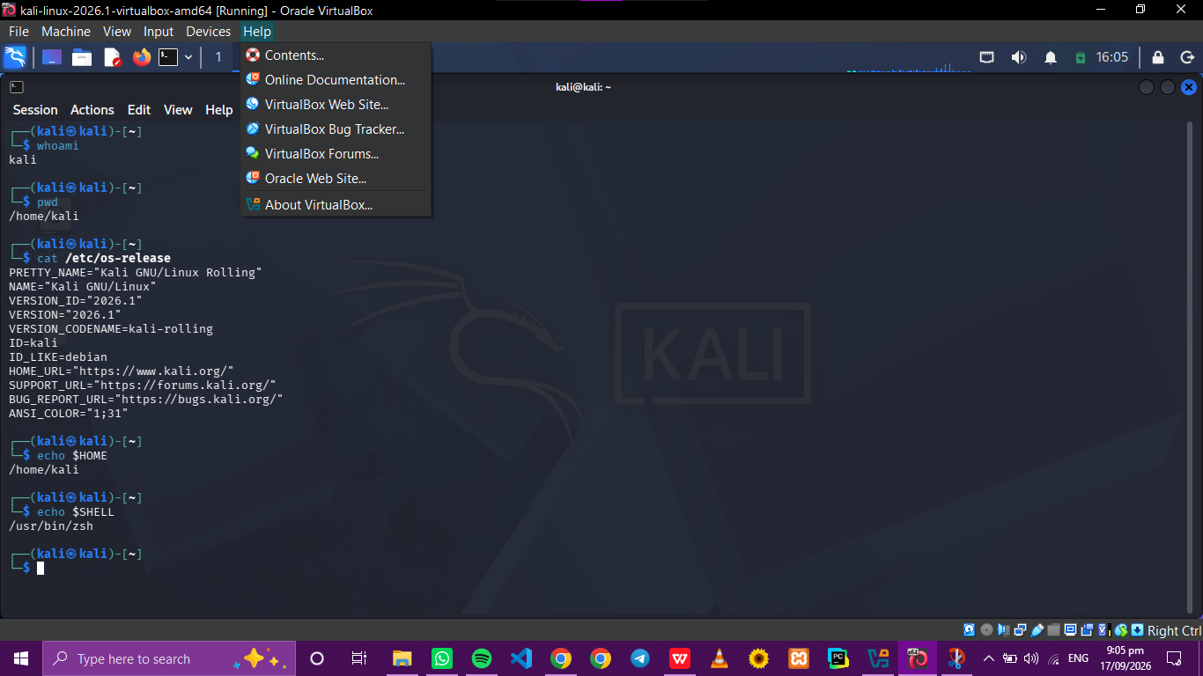
These commands were used;
- whoami
- hostname
- pwd
- cat /etc/os-release
- echo $HOME
- echo $SHELL
This helps check the identification of the computer. It also helps the security personnel know the system characteristics

TASK 2: File and Directory Management

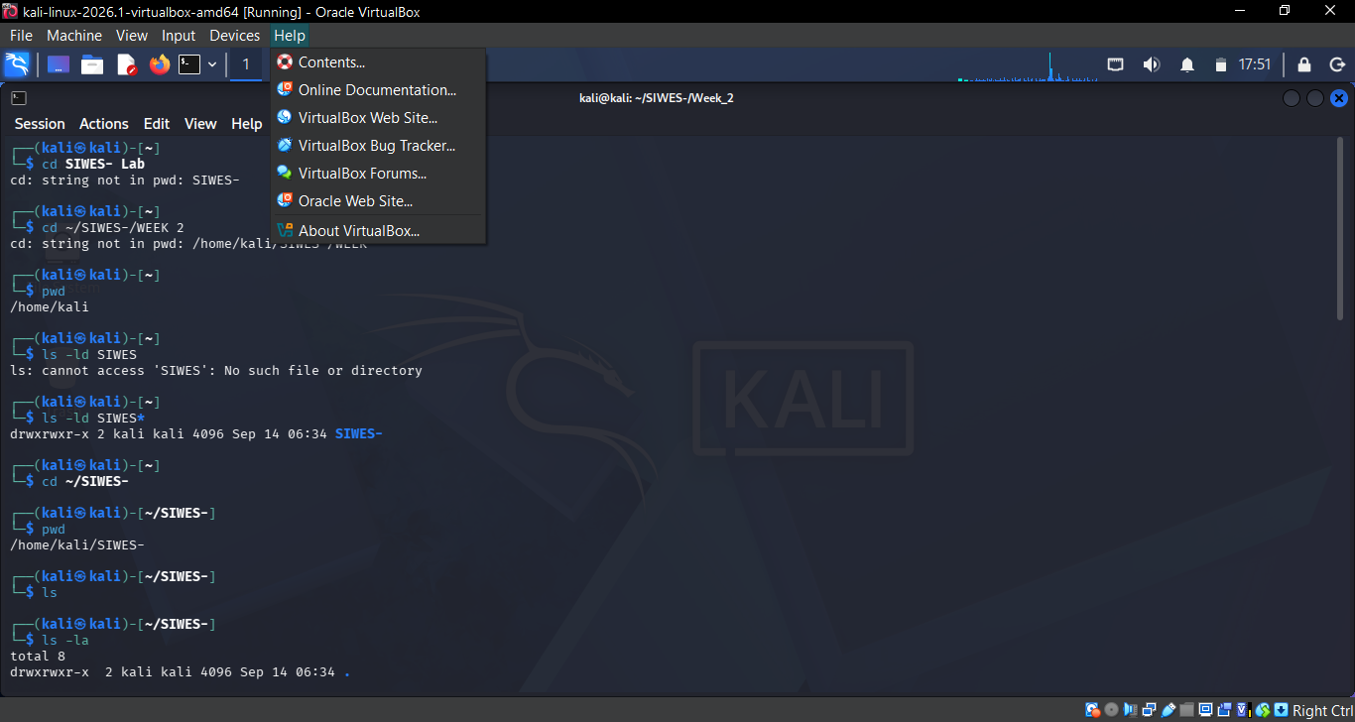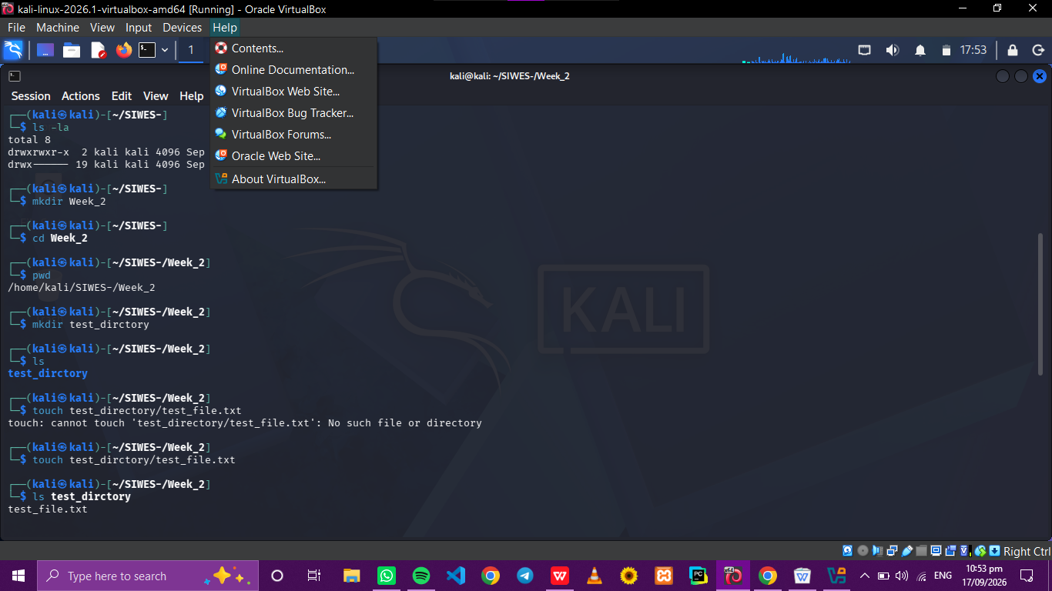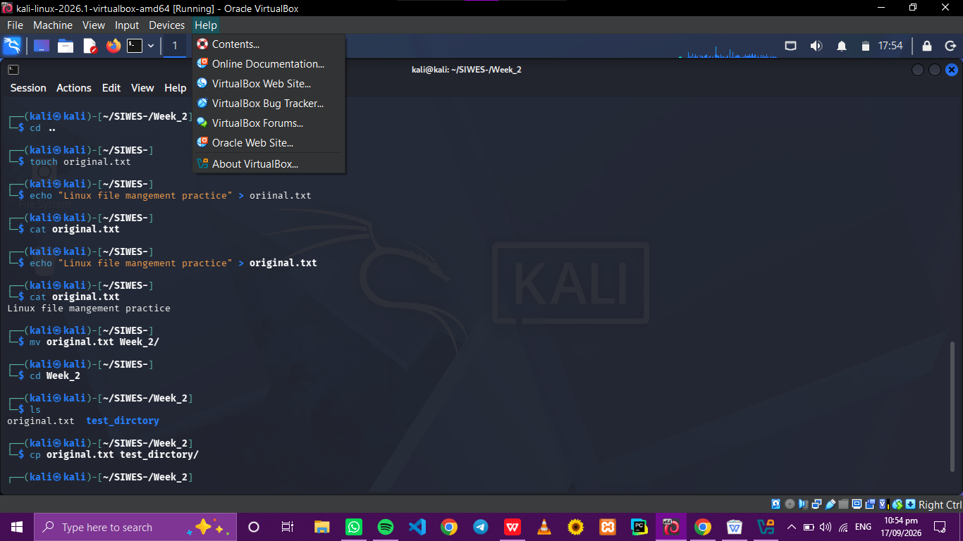

These commands were used;
- ls
- ls -la
- cd
- mkdir
- touch
- cat
- cp
- mv
- rm

RELEVANCE
File management is important because security personnels work regularly with config files, logs, scripts and othe system information. It is important to use commands carefully because incorrect use can lead to data loss

TASK 3: Users, Groups and Permissions
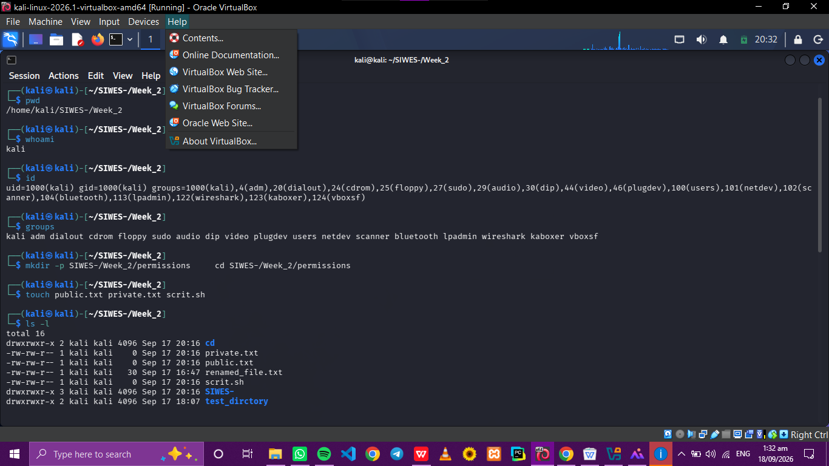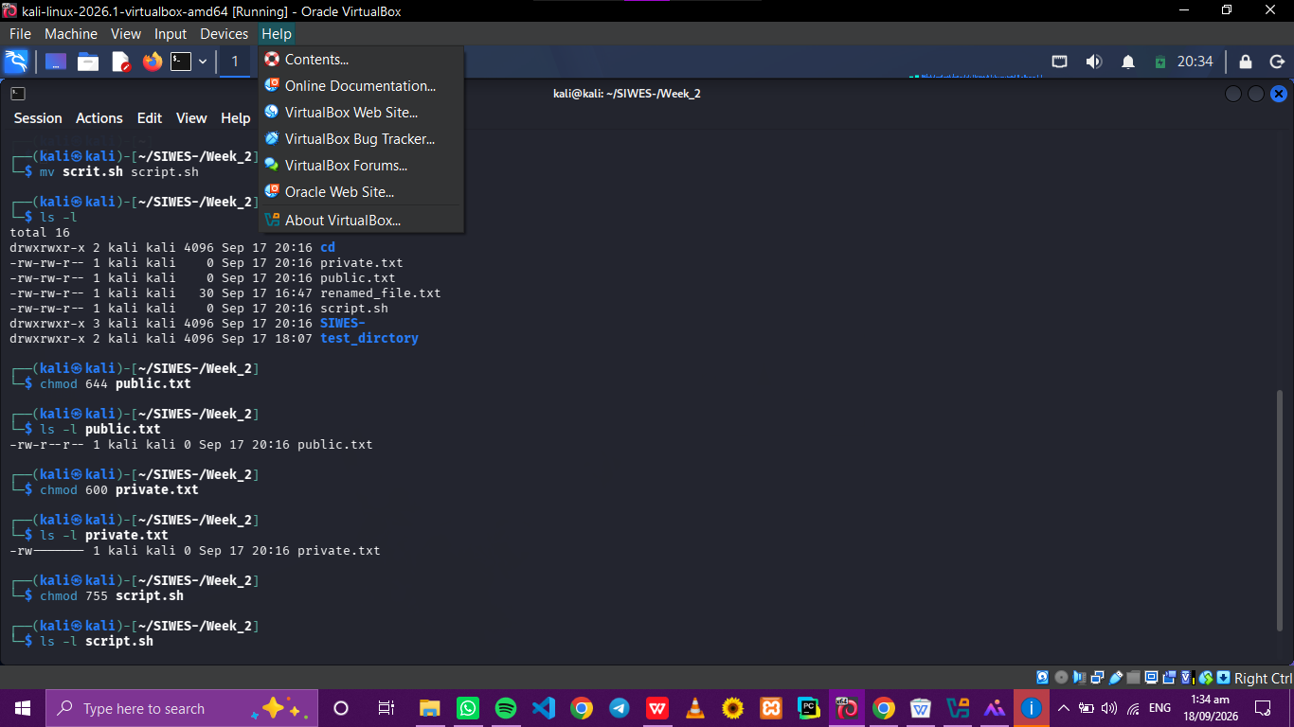

Commands used;
- whoami
- id
- groups
- chmod
- ls -l

FILE | PERMISSION | MEANING
public.txt | 644 | Owner can read/write while other people can only view or read
private.txt | 600 | The owner can read/write while groups and others have no access
script.sh | 755 | Owner can read/write/execute while group and others can read/execute

Meaning of Permission Symbols
- r- read
- w- write
- x- execute

Relevance
File permissions are very important in system security. Incorrect permissions can lead to unauthorised users to read, modify or execute files. It also supports the prnciple of least privilege where the users should only receive access necessary to perform their tasks

TASK 4: Process investigation 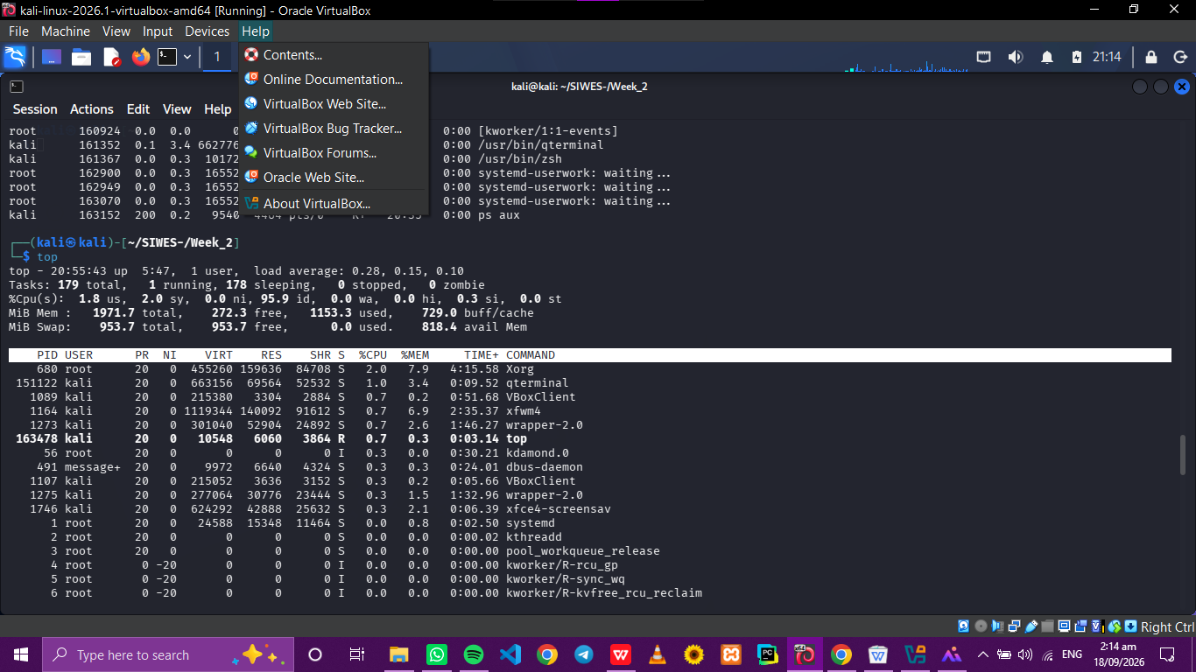

Commands used;
- ps
- ps aux
- top

PROCESS NAME | PID | USER
Xorg | 680 | root
qterminal | 151122 | kali
vBoxclient | 1089 | kali
xfwm4 | 1164 | kali
Wrapper-2.0 | 1273 | kali

Xorg- it provides the graphical display/server for kali
vBoxclient- supports communication/integration between kali and the virtual box

Relevance
Security personnel inspect the running processes to basically understand what is active on a system

TASK 5: Service Investigation

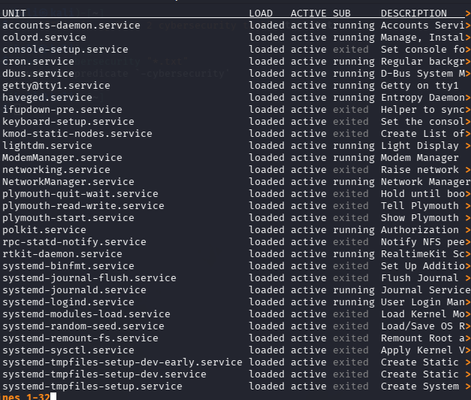

Command used;
systemctl –type=service

SERVICE | FUNCTION | NETWORK COMMUNICATION
Network Manager Service | Manages network connections like wifi and ethernet | YES
cron.service | Runs background | MAYBE
systemd-journald.service | Manages system logs | MAYBE

Relevance
Service can affect the attack surface of a workstation, therefore Services should be understood before they are stopped.

TASK 6:
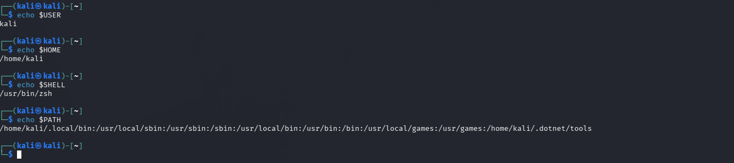

Commands used;
- echo $USER
- echo $HOME
- echo $SHELL
- echo $PATH

VARIABLE | OUTPUT | MEANING
echo $USER | Kali | User that is logged in
echo $HOME | /home/kali | Home directory
echo $SHELL | /usr/bin/zsh | Shell being used
echo $PATH | /home/kali/local/bin:/usr/localbin:/.. | Directories linux searches for executable commands
Relevance
The variable $USER shows the curent user as kali and its home directory as /home/kali. The variable $SHELL shows which type of shell exactly is being used, which is the Z shell while the $PATH variable shows the directories that linux searches or goes through to execute a command.

TASK 7: File System and Log Exploration
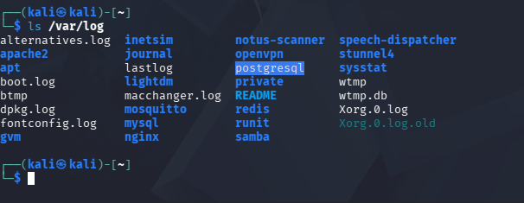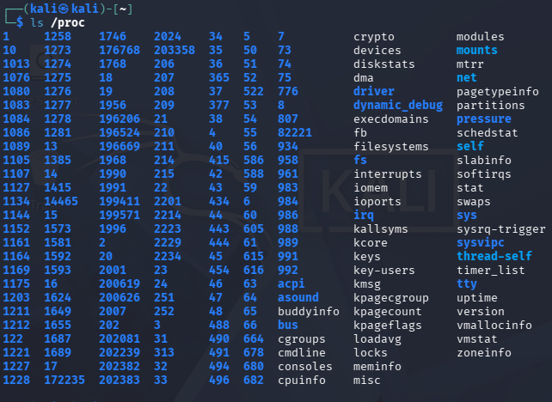

Commands used;
- /home - stores personal files
- /etc - stores config files
- /var stores variable data
- /var/log - stores logs containing records of active systems
- /tmp - used to store temporary files while system is running
- /usr - contains user related programs
- /proc - gives information about running process and system resources

TASK 8: Search and Text Inspection
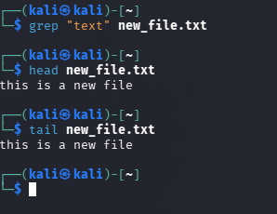
Commands used;
- find ~ -name”*.txt”
- grep “text” filename
- head filename
- tail filename

Relevance
It can be useful to security personnels when inspecting, examining files config information and system logs. And also help locate relevant information without manually opening every file.

- Least previlege- this is important because users and processes should only have the permissione to perform their tasks
- Root access- using root for normal tasks can cause accidental system changes
- File permission- it controls who can read, modify or execute files
- Process monitoring- help identify suspicious or unnecessary activities
- Unnecessary services- increase the system’s attack surface creates points the attacker can target
- System logs- provide useful evidence for monitoring and investigating security incidents
- Linux commands- “cd” because it helped me move from one folder to another

